

**SUMMER 2024**

**APT3090 CRYPTOGRAPHY AND NETWORK SECURITY**

**15 Marks**

**Lab 1: Key Generation Algorithm Prime numbers**

Read about prime numbers, GCD and generation of random numbers

Write a program using any Object oriented programming language to show generation of keys using prime numbers. The program should randomly pick two prime numbers from a given range, the first output random number is p and the second one is q

**Evaluation Criteria**

1. **Random Generation of p, q**
2. **Correctness of the code**

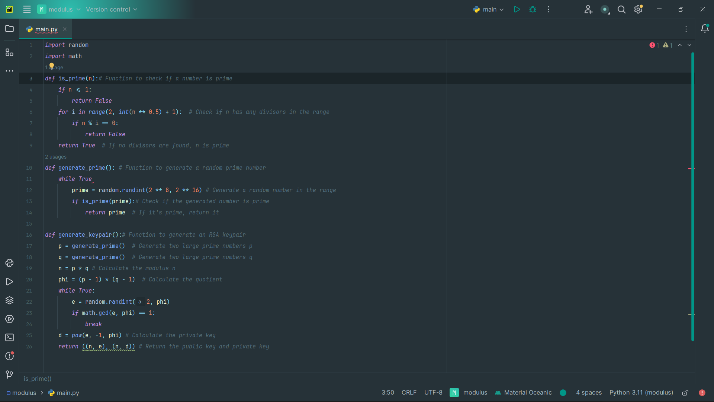

**Lab 2: Euler’s Totient function**

Read about relatively prime numbers, Eulers and totient

**Euler's theorem** states that, “if p and q are relatively prime, then”, where φ is **Euler's** totient function for integers. That is, is the number of non-negative numbers that are less than q and relatively prime to q.Euler’s Totient function Φ(n) for an input n is count of numbers in {1, 2, 3, …, n} that are relatively prime to n, i.e., the numbers whose GCD (Greatest Common Divisor) with n is 1.

# Modify Lab 1 program and write a program for finding Euler Totient Function Values

**Evaluation Criteria**

1. **Random Generation of p, generation of Euler Totient Function Values**
2. **Prepare one lab report showing the code and the results (screenshots) and explanation of your two algorithms.**